**Changed sex to factor**

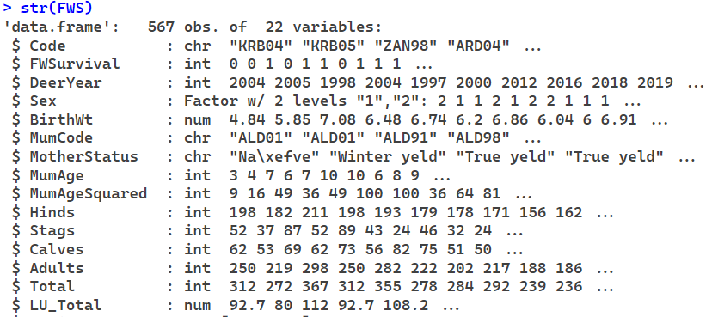

**Fixed mother’s age**

After fixing mother’s age, age and age squared are now both significant in all models, which would make a lot more sense. There seems to be no difference between scaled and unscaled models after this change too. I tried running glmer models again with the fixed data but it’s still encountering convergence issues so I won’t be using them for now.

The livestock unit models now give the lowest AIC values instead of Hinds. Although none of the density measures gave significant coefficients (p<0.05), the livestock unit models are the closest to being significant.

**Summary**

|  | **glmmTMB** | **glmmTMB**  **Scaled** | **glmmTMB**  **No Birthwt** | **glmmTMB**  **No Birthwt**  **Scaled** |
| --- | --- | --- | --- | --- |
| **Hinds** | **-0.015 (p=0.10)** | **-0.32 (p=0.10)** | **-0.013 (p=0.15)** | **-0.27 (p=0.14)** |
| **Adults** | **0.0082 (p=0.17)** | **0.25 (p=0.17)** | **0.0086 (p=0.14)** | **0.26 (p=0.14)** |
| **Total** | **0.0084 (p=0.11)** | **0.29 (p=0.12)** | **0.0088 (p=0.088)** | **0.30 (p=0.090)** |
| **Livestock Units** | **0.028 (p=0.065)** | **0.35 (p=0.066)** | **0.030 (p=0.052)** | **0.36 (p=0.052)** |

**AIC**

|  | **glmmTMB** | **glmmTMB**  **Scaled** | **glmmTMB**  **No Birthwt** | **glmmTMB**  **No Birthwt**  **Scaled** |
| --- | --- | --- | --- | --- |
| **Hinds** | **484.3** | **484.3** | **519.1** | **519.1** |
| **Adults** | **485.3** | **485.3** | **519.2** | **519.2** |
| **Total** | **484.7** | **484.7** | **518.4** | **518.4** |
| **Livestock Units** | **483.6** | **483.6** | **517.3** | **517.3** |

**Hinds**

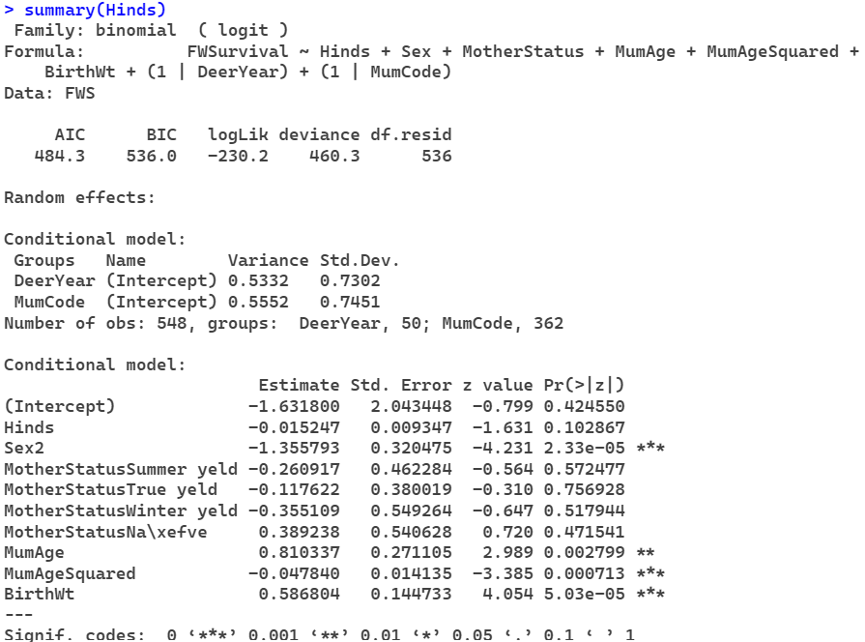

**Adults**

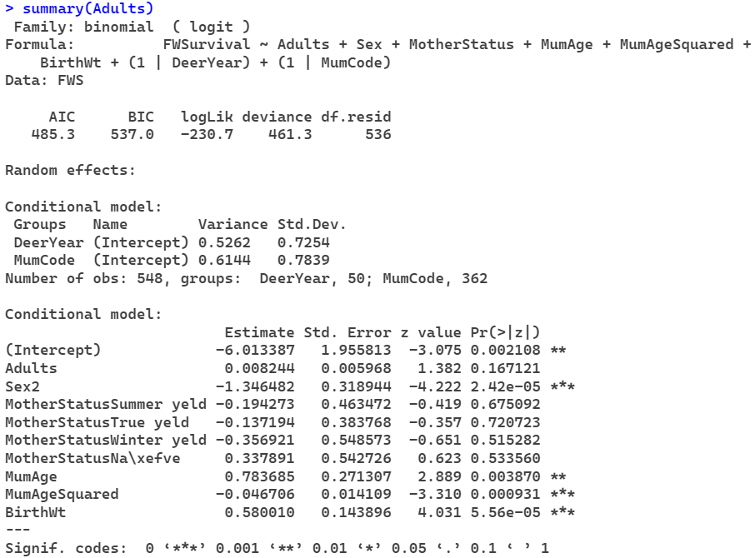

**Total**

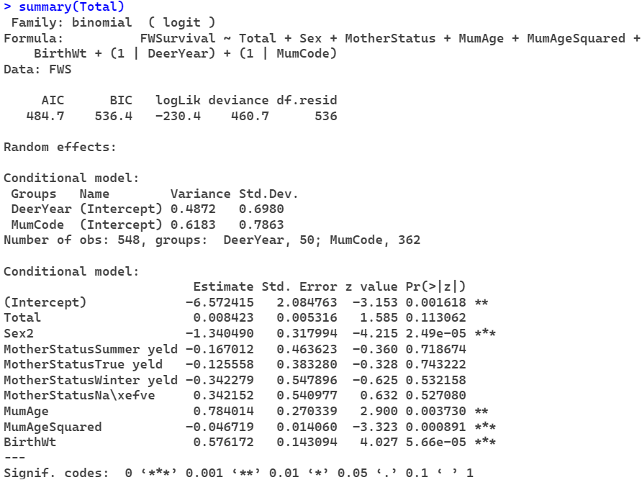

**Livestock Units**

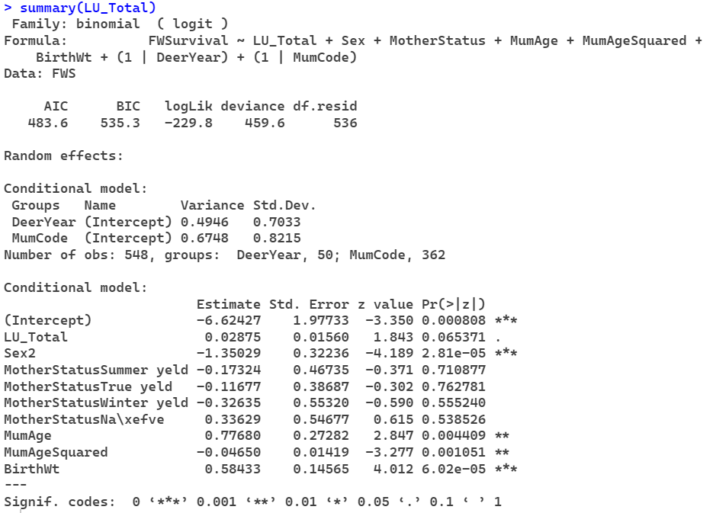

**Scaled Hinds**

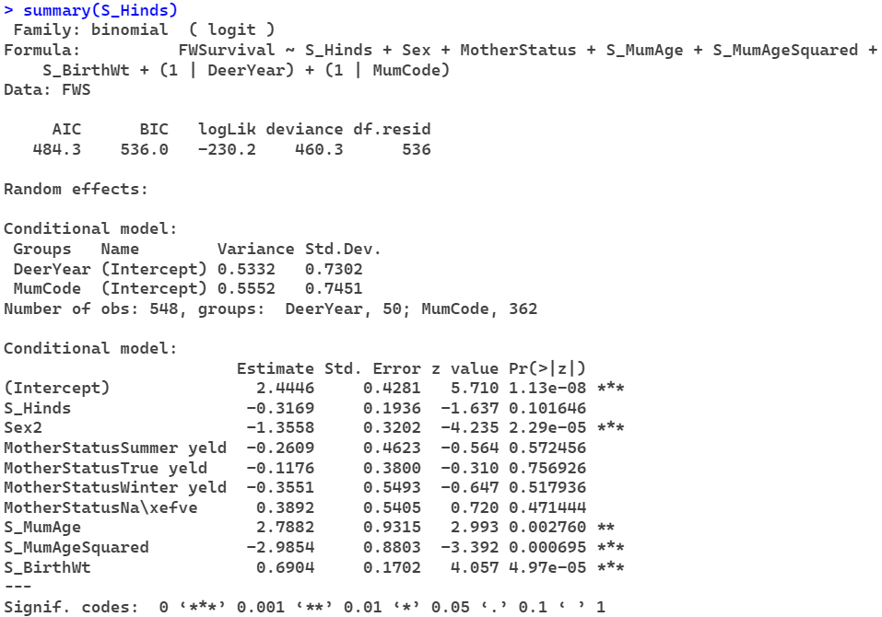

**Scaled Adults**

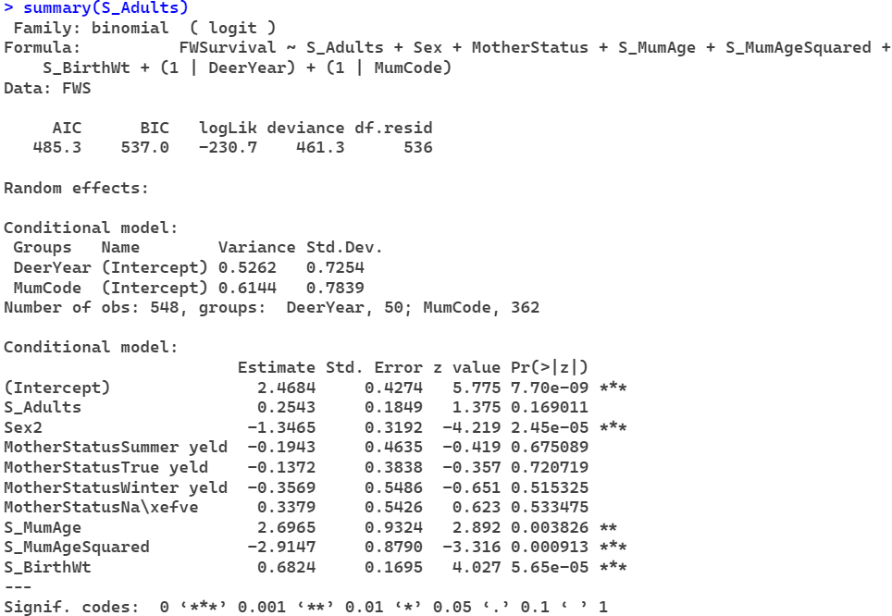

**Scaled Total**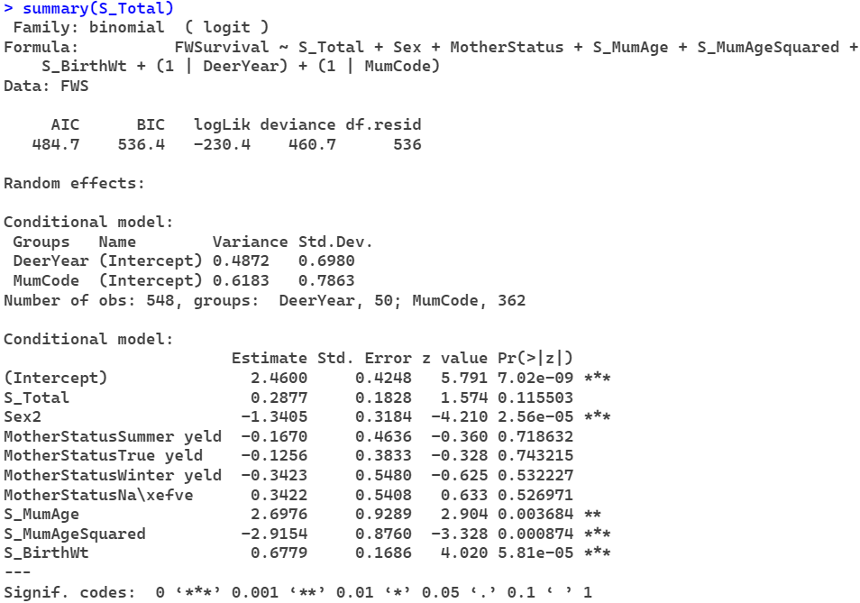

**Scaled Livestock Units**

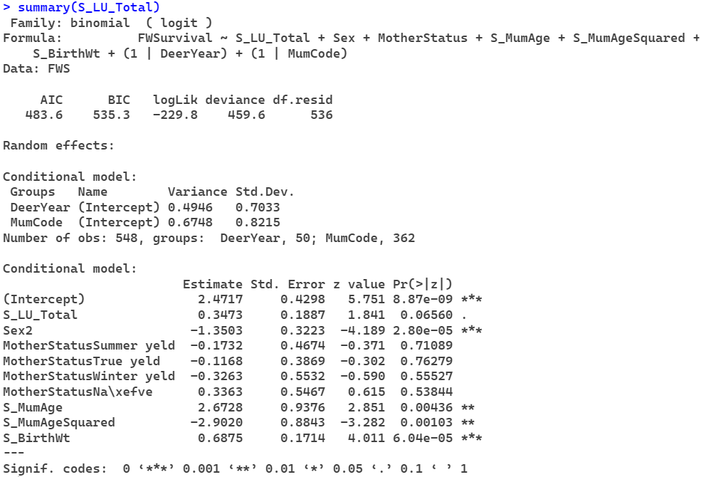

**Hinds w/o birth weight**

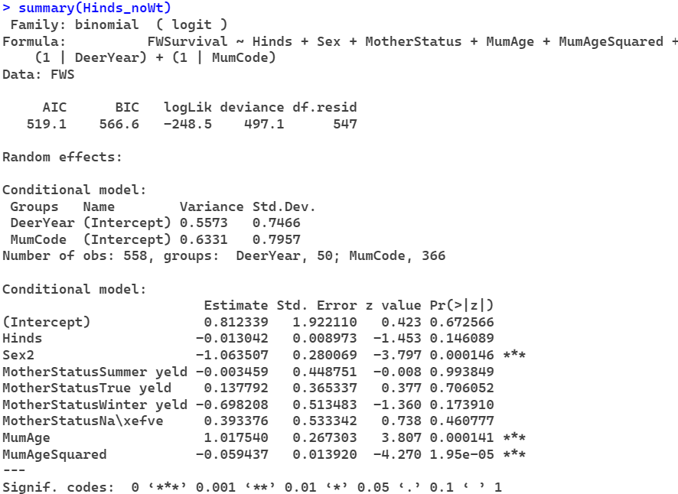

**Adults w/o birth weight**

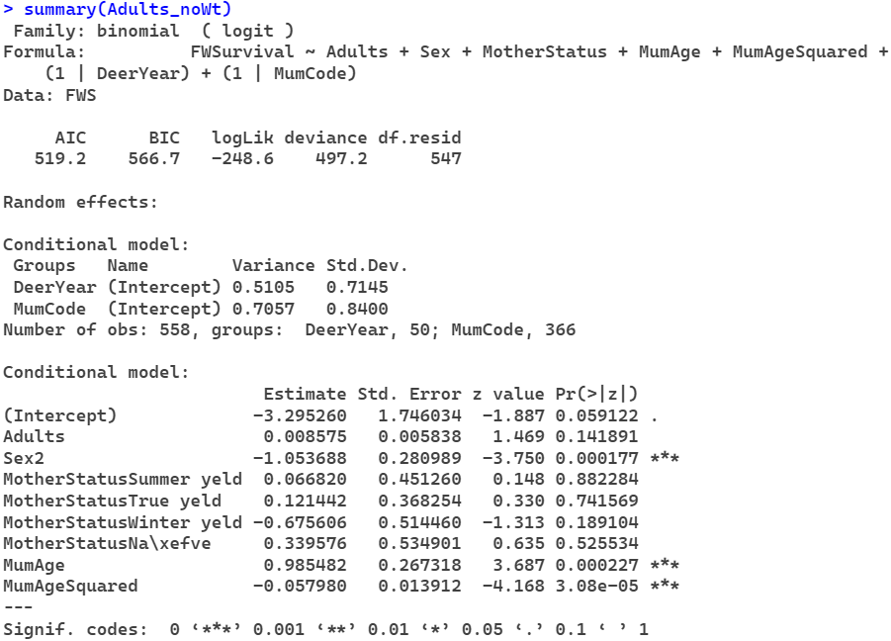

**Total w/o birth weight**

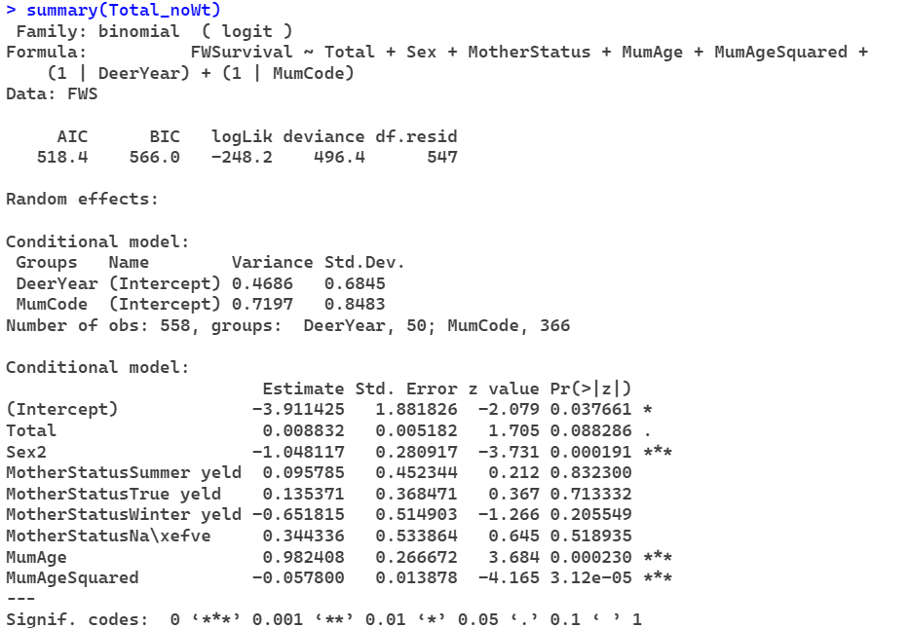

**Livestock Units w/o birth weight**

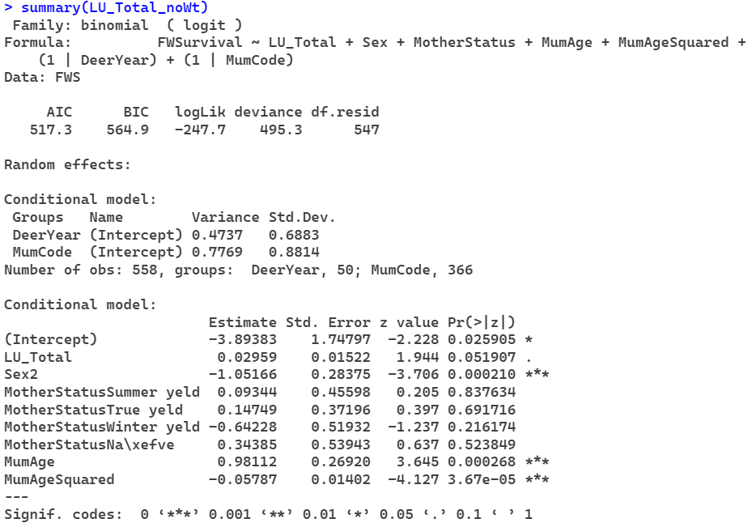

**Scaled Hinds w/o birth weight**

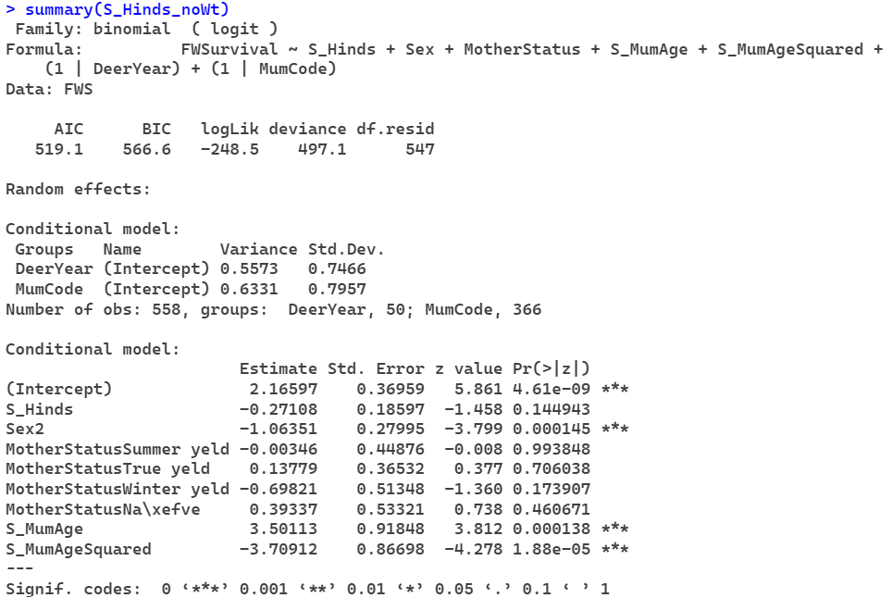

**Scaled Adults w/o birth weight**

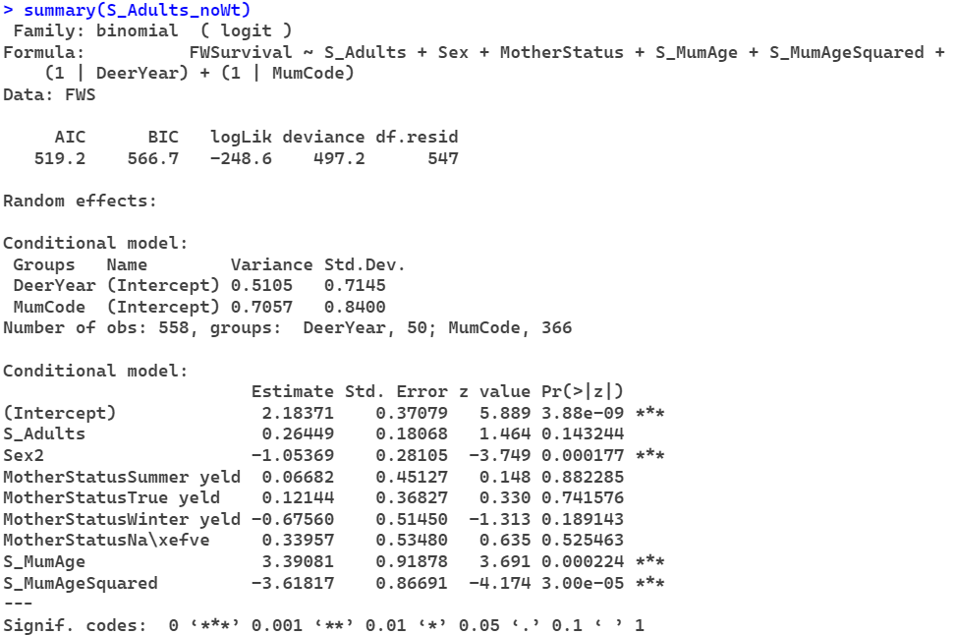

**Scaled Total w/o birth weight**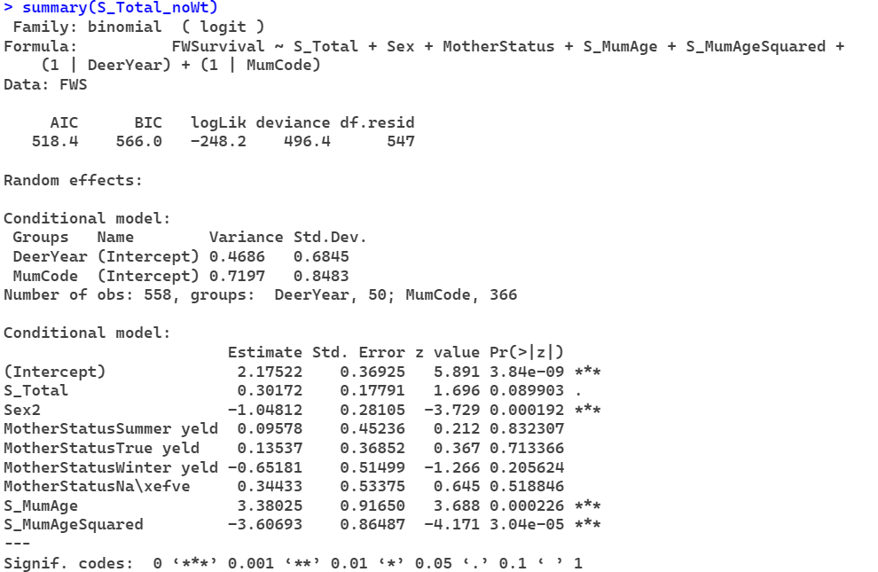

**Scaled Livestock Units w/o birth weight**

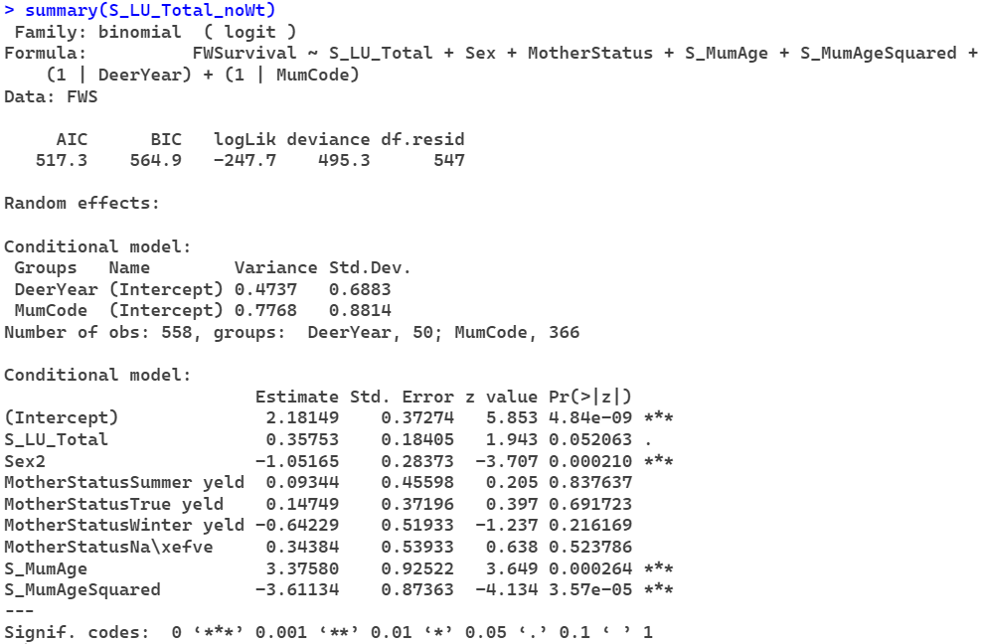

**fecundity : Individual basis per year**

**Fit mum identity and fit mum status**

**External effect of mum ID**